

Mini Project Report – 05

Master of Computer Application – General Semester – I

Sub: Frontend Frameworks and Technologies Topic: Respsonsive College Event Page

By
Name: Ashraj Singh Rana
Reg no.: PROV/ASAC/MCA/7/26/058

Faculty Name: VEERA RAGHAV K

Faculty Signature:

Department of Computer Application Alliance University
Chandapura - Anekal Main Road, Anekal Bengaluru - 562 106
August 2026
6

INDEX

Fig No. | Name | Page No.
1. | Introduction | 1
2. | Input code | 2 - 12
3. | Output code | 13
4. | Conclusion | 14

INTRODUCTION
The Alliance University College Event Webpage is a responsive web-based project developed using HTML and CSS. The main purpose of this project is to provide students and participants with a simple and organized platform to view information about a college event and register for it.
The webpage includes a responsive navigation bar, event banner, event highlights, venue information, a three-day event schedule, guest speaker cards, registration form, and contact section. The website is designed to provide a clear and user-friendly interface across different screen sizes such as desktops, tablets, and mobile devices. CSS media queries are used to make the webpage responsive at tablet and mobile breakpoints.
This project demonstrates the practical implementation of HTML structure, CSS styling, responsive design, navigation, forms, tables, cards, and layout techniques. The project focuses on creating an attractive and accessible college event webpage while maintaining a structured and responsive design.

INPUT CODE
<!DOCTYPE html>
<html lang="en">

<head>
<meta charset="UTF-8">
<meta name="viewport" content="width=device-width, initial-scale=1.0">
<title>responsive college event page</title>
<style>
* {
box-sizing: border-box;
}

body {
margin: 0;
font-family: Arial, sans-serif;
background-color: #f2f5f0;
color: #26332d;
}

.header {
background-color: #285943;
color: white;
text-align: center;
padding: 20px;
}

.top {
margin: 0;
font-size: 28px;
}

nav {
background-color: #26332d;
text-align: center;
padding: 12px;
}

nav a {
color: white;
text-decoration: none;
margin: 0 12px;
font-size: 16px;
}

nav a:hover {
color: #f2c14e;
}

main {
max-width: 900px;
margin: auto;
}

section {
background-color: white;
margin: 20px;
padding: 25px;
border-radius: 8px;
box-shadow: 0 2px 6px #00000018;
}

.Banner {
text-align: center;
background-color: #fff3d2;
}

.Banner h1 {
color: #285943;
font-size: 35px;
}

.Banner p {
font-size: 18px;
}

button,
.register-button {
display: inline-block;
background-color: #e0ad32;
color: #26332d;
border: none;
padding: 10px 18px;
border-radius: 5px;
cursor: pointer;
text-decoration: none;
}

button:hover,
.register-button:hover {
background-color: #c89520;
}

table {
width: 100%;
border-collapse: collapse;
}

th,
td {
border: 1px solid #d4dfd5;
padding: 10px;
text-align: left;
}

th {
background-color: #285943;
color: white;
}

.speaker {
display: inline-block;
width: 45%;
padding: 15px;
margin: 10px 1%;
background-color: #e7f0e8;
border-radius: 6px;
border-left: 4px solid #e0ad32;
transition: 0.3s;
}

.speaker:hover {
transform: translateY(-3px);
}

.speaker h3 {
color: #285943;
}

input {
padding: 8px;
width: 250px;
border: 1px solid #aab8ac;
border-radius: 4px;
}

label {
display: inline-block;
width: 70px;
}

footer {
background-color: #26332d;
color: white;
text-align: center;
padding: 15px;
}

@media (max-width: 600px) {
nav a {
display: block;
margin: 8px;
}

section {
margin: 10px;
padding: 15px;
}

.Banner h1 {
font-size: 28px;
}

.speaker {
width: 100%;
margin: 8px 0;
}

table {
font-size: 14px;
}

input {
width: 100%;
}

label {
width: 100%;
margin-bottom: 5px;
}
}
</style>
</head>

<body>

<header class="header">
<h1 class="top">responsive college event page</h1>
</header>
<nav>
<a href="#home">home</a>
<a href="#details">details</a>
<a href="#schedule">Schedule</a>
<a href="#speakers">Speaker</a>
<a href="#register">Register</a>
<a href="#contact">Contact</a>
</nav>
<main>
<section id="home" class="Banner">
<h1>College Tech Fest 2026</h1>
<p>Welcome to our College Event</p>
<a class="register-button" href="#register">Register Now</a>
</section>

<section id="details">
<p><b>Date:</b> 15 October 2026</p>
<p><b>Time:</b> 10:00 AM</p>
<p><b>Venue:</b> College Auditorium</p>
</section>
<section id="schedule">
<h2>Schedule</h2>

<table>
<tr>
<th>Time</th>
<th>Event</th>
</tr>
<tr>
<td>10:00 AM</td>
<td>Opening Ceremony</td>
</tr>
<tr>
<td>11:00 AM</td>
<td>Technical Session</td>
</tr>
<tr>
<td>1:00 PM</td>
<td>Lunch</td>
</tr>

<tr>
<td>2:00 PM</td>
<td>Project Presentation</td>
</tr>
</table>
</section>
<section id="speakers">
<h2>Speakers</h2>

<div class="speaker">
<h3>Mr. Raghv Sir</h3>
<p>FULL Stack developer</p>
</div>

<div class="speaker">
<h3>Mr. Abhishek</h3>
<p>Ai Expert</p>
</div>
</section>
<section id="register">
<h2>Registration</h2>

<form>

<label for="name">Name:</label>
<input id="name" name="name" type="text" required><br><br>

<label for="email">Email:</label>
<input id="email" name="email" type="email" required><br><br>

<label for="phone">Phone:</label>
<input id="phone" name="phone" type="tel" required><br><br>

<button type="submit">Register</button><br><br>

</form>
</section>
<section id="contact">
<h2>Contact</h2>

<p>Email: aufest@gmail.com</p>
<p>Phone: 9327296666</p>
</section>

</main>

<footer>
<p>© 2026 College Tech Fest</p>
</footer>

</body>

</html>

OUTPUT

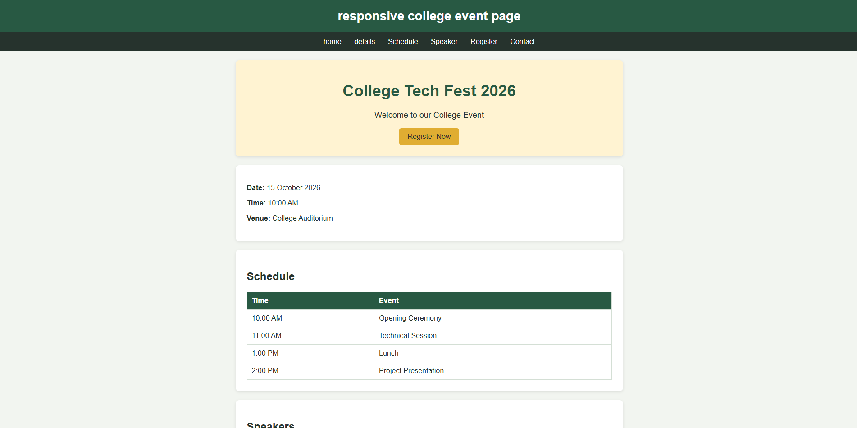

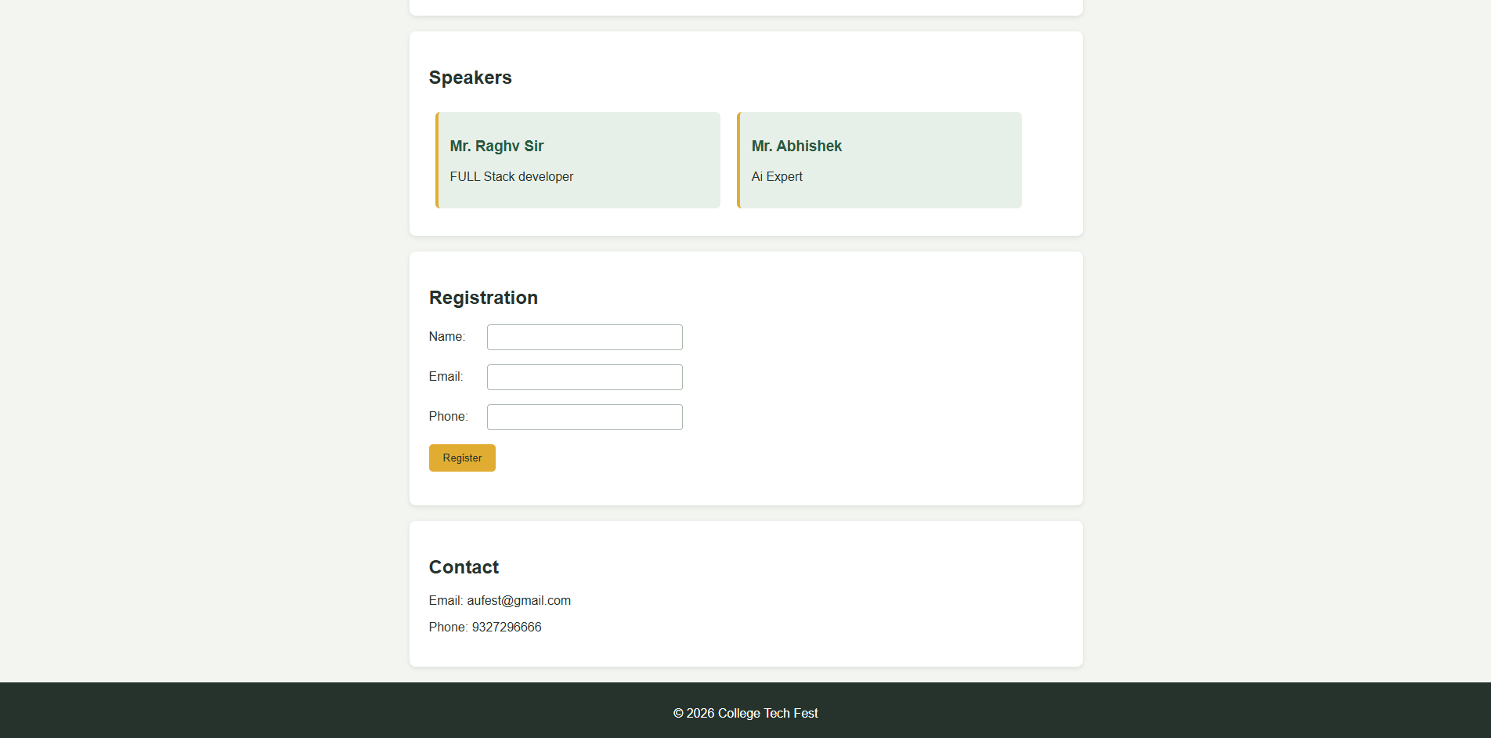

CONCLUSION
The Alliance University College Event Webpage successfully demonstrates how HTML and CSS can be used to develop a structured, attractive, and responsive college event website. The project includes all the major components required for an event webpage, including event details, schedule, speakers, registration, and contact information.
Through this project, practical knowledge of HTML5, CSS3, responsive layouts, media queries, forms, tables, navigation bars, and card-based designs was applied. The webpage adapts to desktop, tablet, and mobile screen sizes, making the information easily accessible to users on different devices.
Overall, the project provided practical experience in developing a complete responsive webpage from the ground up and helped strengthen understanding of frontend web development and responsive design principles.

